NAME : Donald McLaughlin

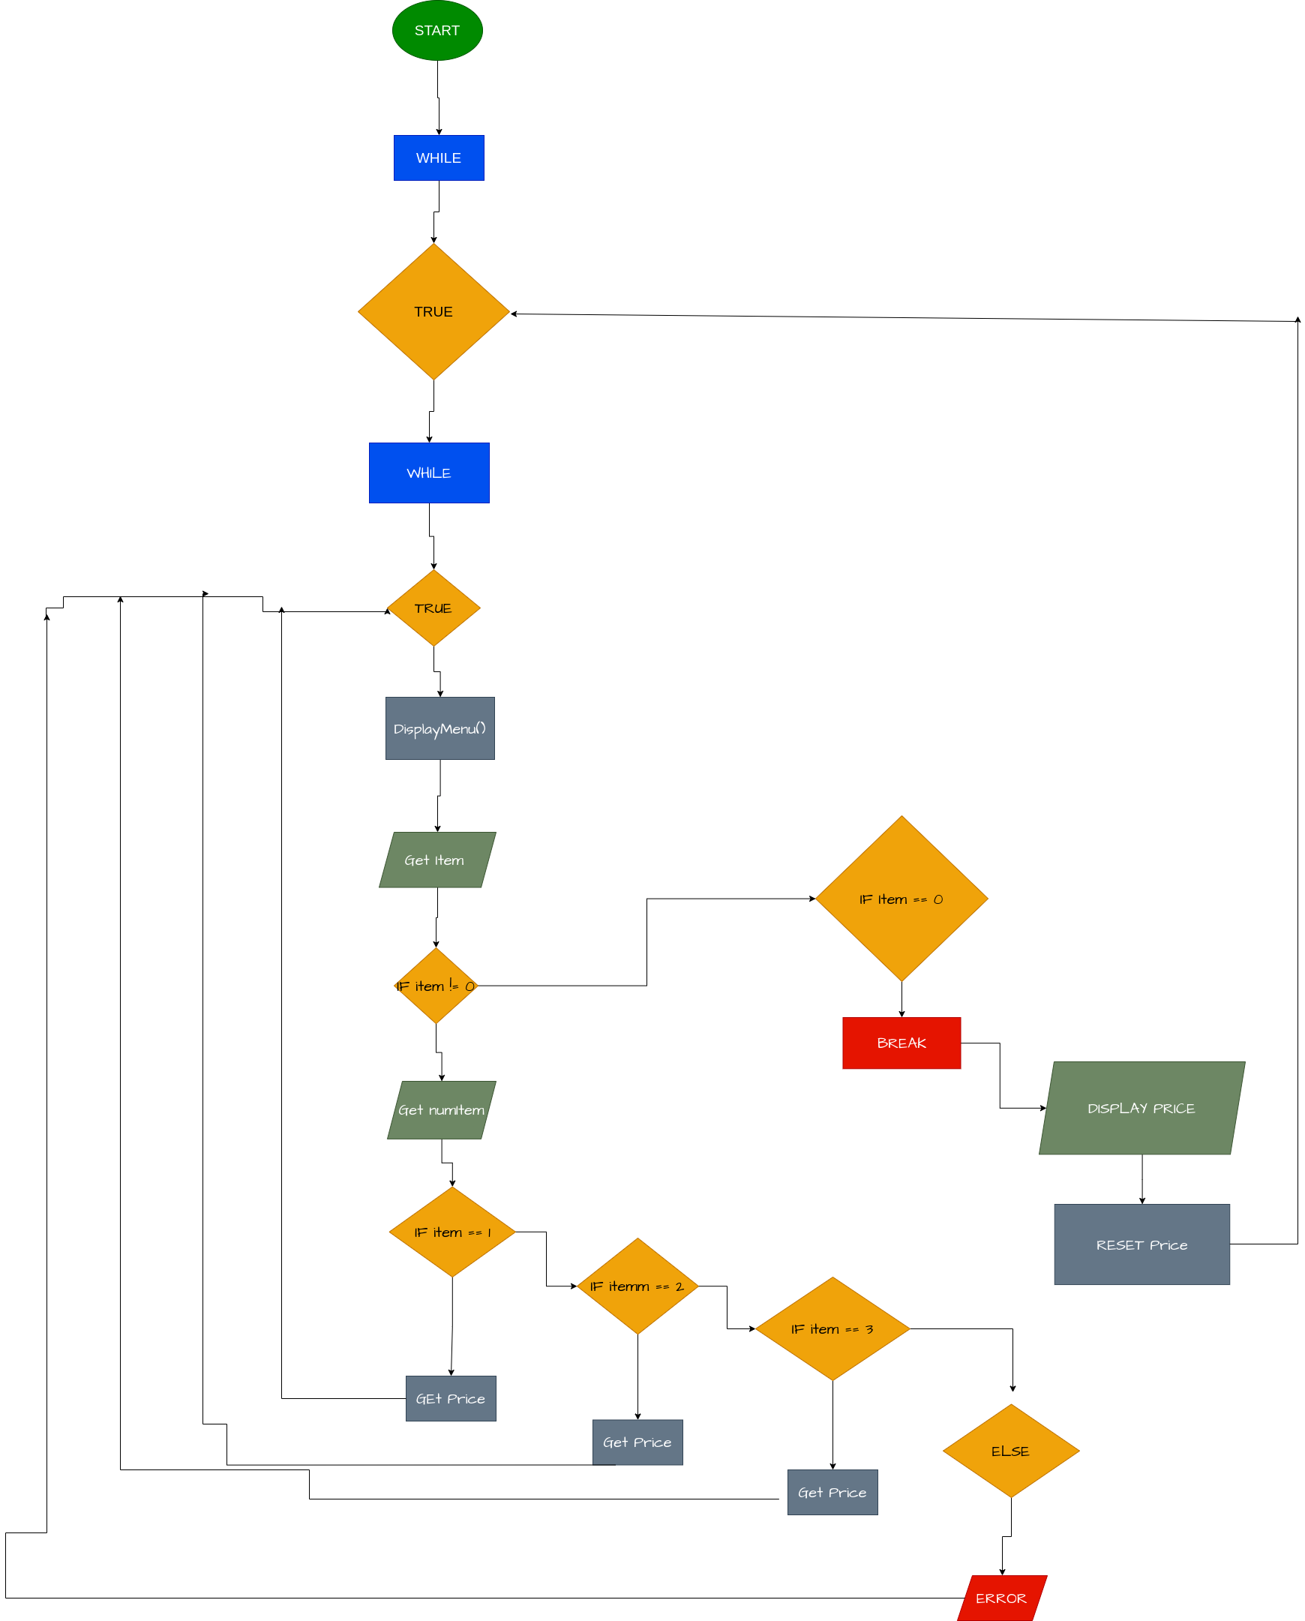

CSCI1010-Project-1-Fast-Food-Checkout
Link to project Github to view repository and instructions in markdown format: https://github.com/don1997/CSCI1010-Project-1-Fast-Food-Checkout

Program Summary
This program displays a menu and takes user input depending on their choice. The total price of the items selected is calculated and the next customer entry is ready to be entered in.

INSTRUCTIONS
- On program initialization a menu listed with the item number, item name, and item price will be listed.
- At the bottom of the menu the menu the user should follow the instruction prompted on the bottom.
- After reading the prompt the user should enter the integers 1, 2, 3, or 0 to the right of the arrow displayed.
- The option 0 is only used to exit out and get the total only.
- If the options 1, 2, or 3 are selected.
- Then another option will be displayed asking the user to enter the amount of the item they selected they want.
- After the user has entered an amount. The user can then enter their next desired item or exit out and get their total.
- After the user has their total displayed the program is reset and ready for the next user.

WARNING
If user enters elements other than integers such as characters or strings. Use ctrl+c to terminate program.

